Chapter 5, Problem 1
What is a thermally activated process? What is the activation energy for such a process?

Chapter 5, Solution 1
A thermally active process is one which requires a definite amount of thermal energy to overcome an activation energy barrier and enter the reactive state.

Chapter 5, Problem 2
Write an equation for the number of vacancies present in a metal at equilibrium at a particular temperature and define each of the terms. Give the units for each term and use electron volts for the activation energy.

Chapter 5, Solution 2
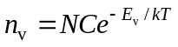
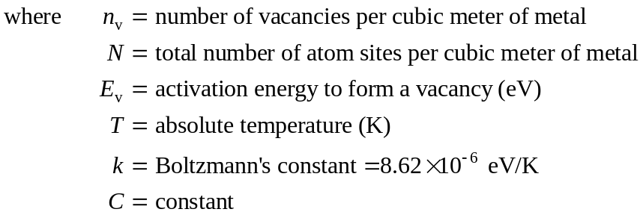

Chapter 5, Problem 3
Write the Arrhenius rate equation in the (a) exponential and (b) common logarithmic forms.

Chapter 5, Solution 3
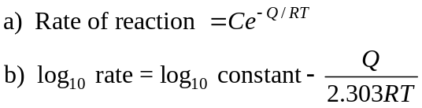

Chapter 5, Problem 4
Draw a typical Arrhenius plot of log₁₀ of the reaction rate versus reciprocal absolute temperature, and indicate the slope of the plot.

Chapter 5, Solution 4
A typical Arrhenius plot of the logarithmic reaction rate is shown below for the SI absolute Kelvin temperature scale. The relationship between the log₁₀ of the reaction rate and the inverse absolute temperature is linear with a slope of –Q/(2.303R).
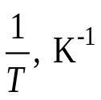
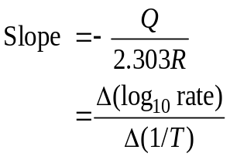
.
Intercept = log₁₀ (const.)
log₁₀ of reaction rate
T, K
Error: Reference source not found

Chapter 5, Problem 5
Describe the substitutional and interstitial diffusion mechanisms in solid metals.

Chapter 5, Solution 5
During substitutional diffusion of atoms in a solid alloy crystal lattice, solute atoms move into positions of solvent atoms in the matrix through a vacancy mechanism. In interstitial diffusion, small solute atoms move between the interstices of the solvent lattice.

Chapter 5, Problem 6
Write the equation for Fick’s first law of diffusion, and define each of the terms in SI units.

Chapter 5, Solution 6
Fick’s first law of diffusion is given by:

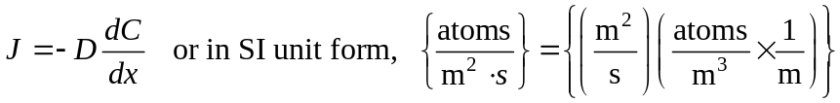
where J = flux or net flow of atoms;
D = proportionality constant called the diffusivity (atomic conductivity) or
diffusion coefficient;
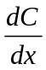 = concentration gradient.

Chapter 5, Problem 7
What factors affect the diffusion rate in solid metal crystals?

Chapter 5, Solution 7
The diffusion rate in solid metal crystals is affected by five factors:

- Type of diffusion mechanism;
- Temperature of diffusion;
- Concentration of the diffusion species (concentration gradient);
- Type of crystal structure;
- Type of crystal imperfections present.

Chapter 5, Problem 8
Write the equation for Fick’s second law of diffusion in solids, and define each of the terms.

Chapter 5, Solution 8
Fick’s second law of diffusion in solids, written for the x-direction, is:

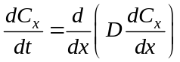
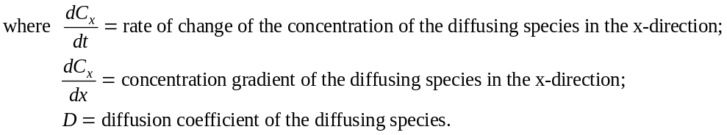

Chapter 5, Problem 9
Write the equation for the solution to Fick’s second law for the diffusion of a gas into the surface of a solid metal crystal lattice.

Chapter 5, Solution 9
Fick’s second law of diffusion, for the diffusion of a gas into the surface of a solid metal crystal lattice is:
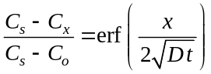

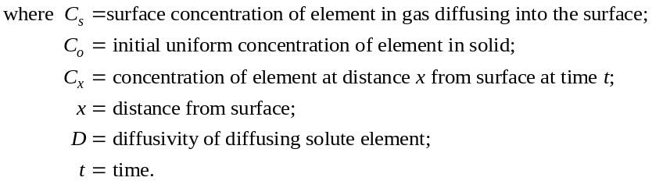

Chapter 5, Problem 10
Describe the gas-carburizing process for steel parts. Why is the carburization of steel parts carried out?

Chapter 5, Solution 10
In the gas carburizing process for steel parts, the parts are placed in a furnace in contact with a gas rich in CO at about 927ºC. The carbon from the gas diffuses into the surface of the steel part and increases the carbon content of the outer surface region of the part. The higher carbon concentration at the surface makes the steel harder in this region. A steel part can thus be produced with a hard outer layer and a tough low carbon steel inner core. This duplex structure is important, for example, for many types of gears.

Chapter 5, Problem 11
(a) Calculate the equilibrium concentration of vacancies per cubic meter in pure copper at 850°C. Assume that the energy of formation of a vacancy in pure copper is 1.0 eV. (b) What is the vacancy fraction at 800°C?

Chapter 5, Solution 11
- In general, the equilibrium number of vacancies is . For copper,

Substituting and assuming E_{v} = 1.00 eV at 1123 K,
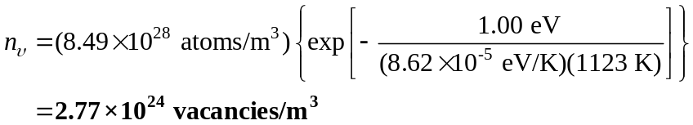

- The vacancy fraction at 1073 K is,

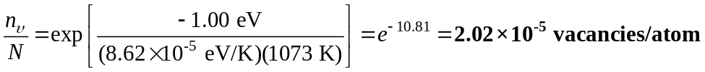

Chapter 5, Problem 12
(a) Calculate the equilibrium concentration of vacancies per cubic meter in pure silver at 750°C. Assume that the energy of formation of a vacancy in pure silver is 1.10 eV. (b) What is the vacancy fraction at 700°C?

Chapter 5, Solution 12
- The equilibrium number of vacancies is calculated as 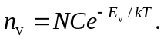 Thus for silver,

Substituting and assuming E_{v} = 1.10 eV for vacancies formed at 1023 K,

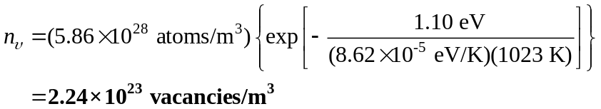

- The vacancy fraction at 973 K is,

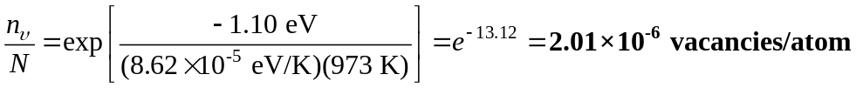

Chapter 5, Problem 13
Determine the diffusion flux of zinc atoms in a solid solution of zing in copper between two points A and B, µm apart, at 500°C. C_{A} = 10²⁶ atoms/m³ and C_{B} = 10²⁴ atoms/m³.

Chapter 5, Solution 13

Chapter 5, Problem 14
The diffusion flux of copper solute atoms in aluminum solvent from point A to point B, 10 µm apart, is 4 × 10¹⁷ atoms/ (m² · s) at 500°C. Determine (a) the concentration gradient and (b) difference in the concentration levels of copper between the two points.
Chapter 5, Solution 14
Copper in Aluminum T = 500°C
A J B
10µm
a)
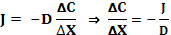
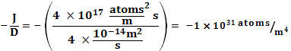
b)

Chapter 5, Problem 15
Consider the gas carburizing of a gear of 1018 steel (0.18 wt %) at 927°C (1700°F). Calculate the time necessary to increase the carbon content to 0.35 wt % at 0.40 mm below the surface of the gear. Assume the carbon content at the surface to be 1.15 wt % and that the nominal carbon content of the steel gear before carburizing is 0.18 wt %. D (C in γ iron) at 927°C = 1.28 × 10⁻¹¹ m²/s.

Chapter 5, Solution 15
The time required for this diffusion process is calculated using Fick’s second law,

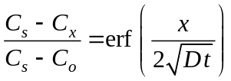

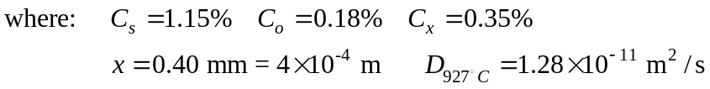

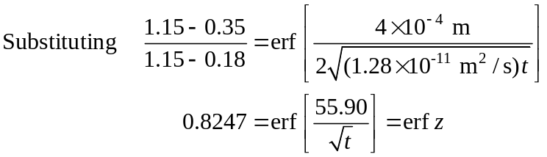

Interpolating from Table 5.3,
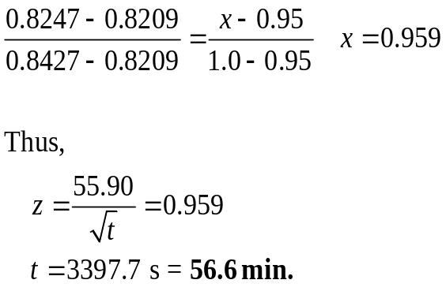

erf z | z
0.8209 | 0.95
0.8247 | x
0.8427 | 1.0

Chapter 5, Problem 16
The surface of a steel gear made of 1022 steel (0.22 wt % C) is to be gas-carburized at 927°C (1700°F). Calculate the time necessary to increase the carbon content to 0.30 wt % at 0.030 in. below the surface of the gear. Assume the carbon content of the surface to be 1.20 wt %. D (C in γ iron) at 927°C = 1.28 × 10⁻¹¹ m²/s.

Chapter 5, Solution 16
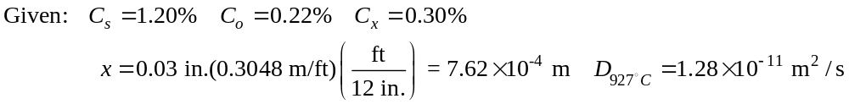

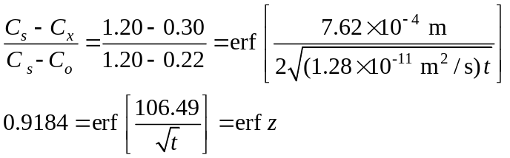

Interpolating from Table 5.3,

erf z | 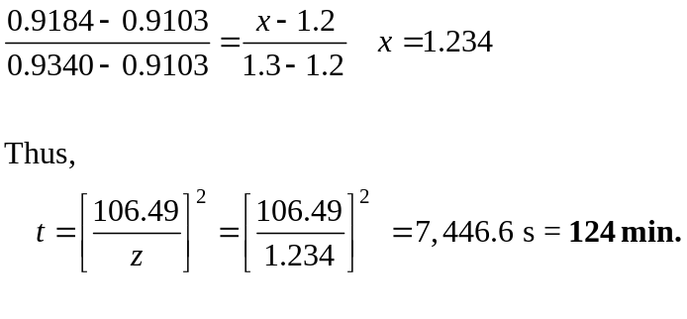  z
0.9103 | 1.2
0.9184 | x
0.9340 | 1.3

Chapter 5, Problem 17
A gear made of 1020 steel (0.20 wt % C) is to be gas-carburized at 927°C (1700°F). Calculate the carbon content at 0.90 mm below the surface of the gear after a 4.0-hour carburizing time. Assume the carbon content at the surface of the gear is 1.00 wt %. D (C in γ iron) at 927°C = 1.28 × 10⁻¹¹ m²/s.

Chapter 5, Solution 17
D (C in λ iron) at 927ºC = 1.28 × 10 ^{–11} m²/s.
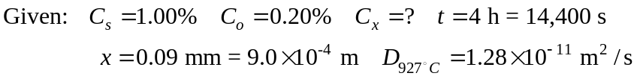
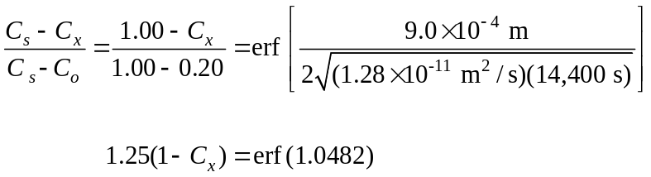

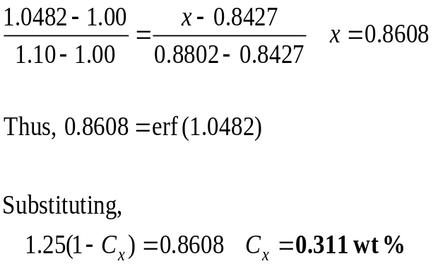
Interpolating from Table 5.3,

erf z | z
0.8427 | 1.00
x | 1.0482
0.8802 | 1.10

Chapter 5, Problem 18
A gear made of 1020 steel (0.20 wt % C) is to be gas-carburized at 927°C (1700°F). Calculate the carbon content at 0.040 in. below the surface of the gear after a 7.0-hour carburizing time. Assume the carbon content at the surface of the gear is 1.15 wt %. D (C in γ iron) at 927°C = 1.28 × 10⁻¹¹ m²/s.

Chapter 5, Solution 18
D (C in λ iron) at 927ºC = 1.28 × 10 ^{–11} m²/s.

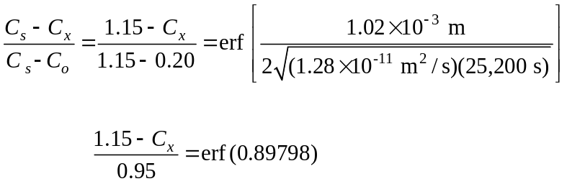

Interpolating from Table 5.3,
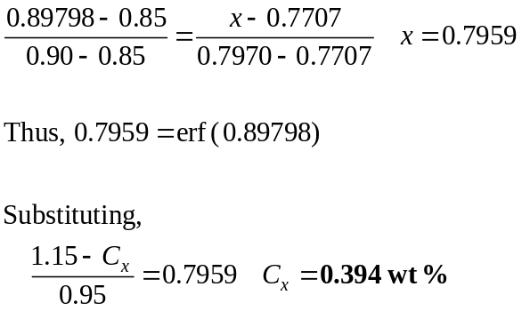
erf z | z
0.7707 | 0.85
x | 0.89798
0.7970 | 0.90

Chapter 5, Problem 19
The surface of a steel gear made of 1018 steel (0.18 wt % C) is to be gas-carburized at 927°C. Calculate the time necessary to increase the carbon content to 0.35 wt % at 1.00 mm below the surface of the gear after an 8.0 hour carburizing time. Assume the carbon content at the surface of the gear is 1.20 wt %. D (C in γ iron) at
927°C = 1.28 × 10⁻¹¹ m²/s.

Chapter 5, Solution 19
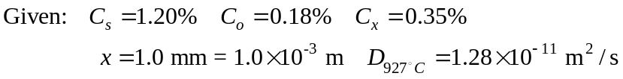

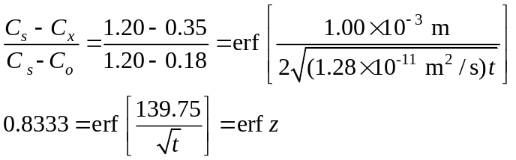

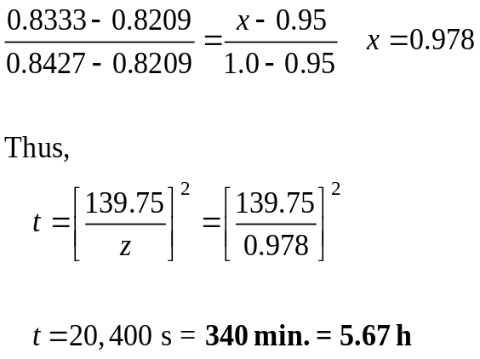
Interpolating from Table 5.3,

erf z | z
0.8209 | 0.95
0.8333 | x
0.8427 | 1.0

Chapter 5, Problem 20
The surface of a steel gear made of 1020 steel (0.20 wt % C) is to be gas-carburized at 927°C. Calculate the carbon content at 0.95 mm below the surface of the gear after an 8.0-hour carburizing time. Assume the carbon content at the surface of the gear is 1.25 wt %. D (C in γ iron) at 927°C = 1.28 × 10⁻¹¹ m²/s.

Chapter 5, Solution 20

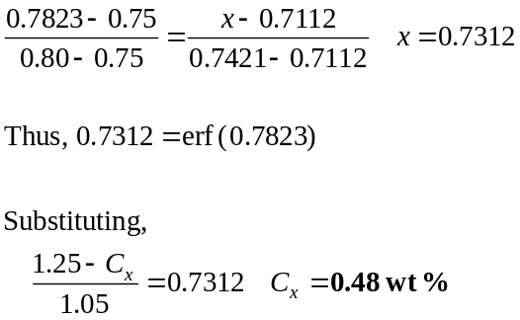
Interpolating from Table 5.3,

erf z | z
0.7112 | 0.75
x | 0.7823
0.7421 | 0.80

Chapter 5, Problem 21
A steel gear made of 1018 steel (0.18 wt % C) is to be gas-carburized at 927°C. If the carburizing time is 7.5 h, at what depth in millimeters will the carbon content be 0.040 wt %? Assume the carbon content at the surface of the gear is 1.20 wt %. D (C in γ iron) at 927°C = 1.28 × 10⁻¹¹ m²/s.

Chapter 5, Solution 21
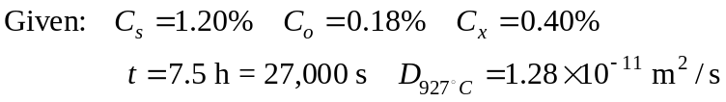

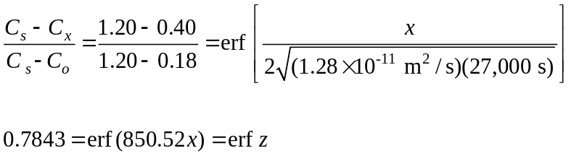
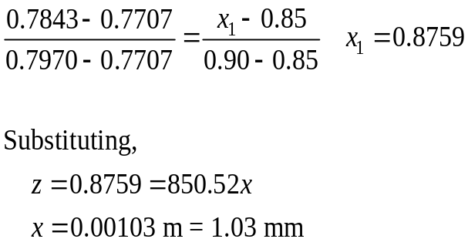
Interpolating from Table 5.3,
erf z | z
0.7112 | 0.75
x | 0.7823
0.7421 | 0.80

Chapter 5, Problem 22
If boron is diffused into a thick slice of silicon with no previous boron in it at a temperature of 1100°C for 5 h, what is the depth below the surface at which the concentration is 10¹⁷ atoms/cm³ if the surface concentration is 10¹⁸ atoms/cm³? D = 4 × 10⁻¹³ cm²/s for boron diffusing in silicon at 1100°C.

Chapter 5, Solution 22
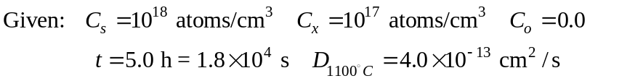

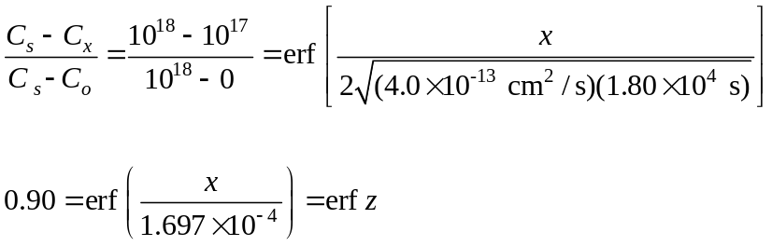
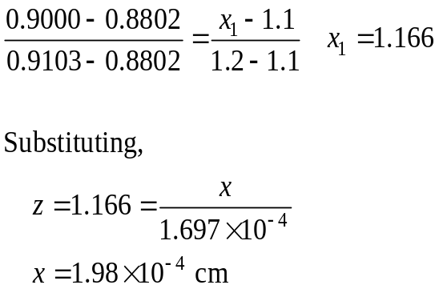
Interpolating from Table 5.3,

erf z | z
0.8802 | 1.1
0.9000 | x
0.9103 | 1.2

Chapter 5, Problem 23
If aluminum is diffused into a thick slice of silicon with no previous aluminum in it at a temperature of 1100°C for 6 h, what is the depth below the surface at which the concentration is 10¹⁶ atoms/cm³ if the surface concentration is 10¹⁸ atoms/cm³?
D = 2 × 10⁻¹² cm²/s for aluminum diffusing in silicon at 1100°C.

Chapter 5, Solution 23
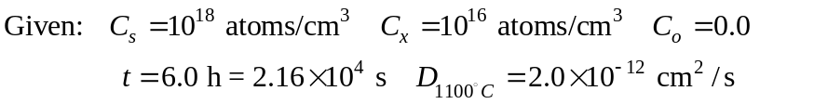

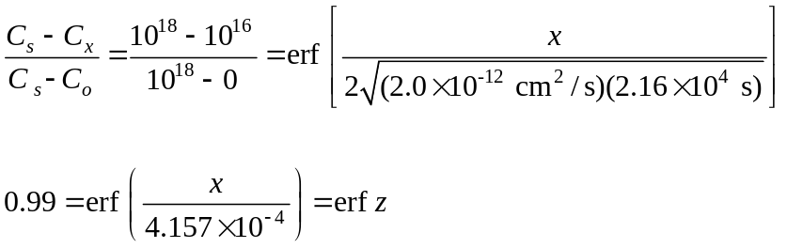

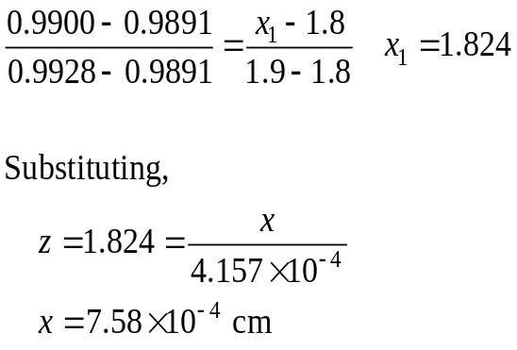
Interpolating from Table 5.3,

erf z | z
0.9891 | 1.8
0.9900 | x
0.9928 | 1.9

Chapter 5, Problem 24
Phosphorus is diffused into a thick slice of silicon with no previous phosphorus in it at a temperature of 1100°C. If the surface concentration of the phosphorus is 1 × 10¹⁸ atoms/cm³ and its concentration at 1 μm is 1 × 10¹⁵ atoms/cm³, how long must be the diffusion time? D = 3.0 × 10⁻¹³ cm²/s for P diffusing in Si at 1100°C.

Chapter 5, Solution 24
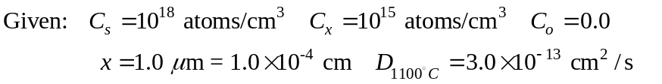

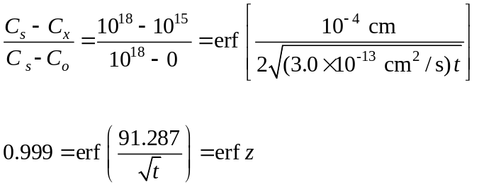

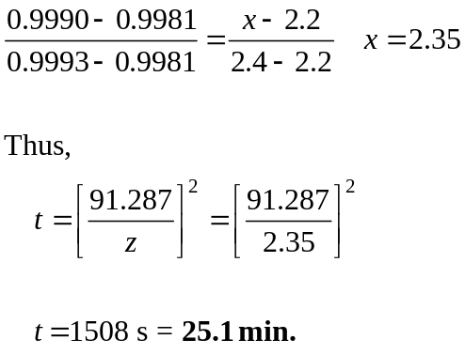Interpolating from Table 5.3,

erf z | z
0.9981 | 2.2
0.9990 | x
0.9993 | 2.4

Chapter 5, Problem 25
If the diffusivity in Prob. 4.53 had been 1.5 × 10⁻¹³ cm²/s, at what depth in micrometers would the phosphorus concentration be 1 × 10¹⁵ atoms/cm³?

Chapter 5, Solution 25
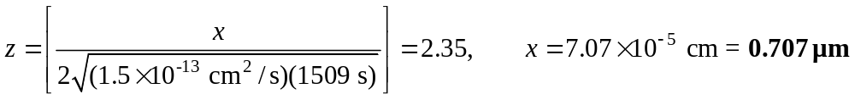

Chapter 5, Problem 26
Arsenic is diffused into a thick slice of silicon with no previous arsenic in it at 1100°C. If the surface concentration of the arsenic is 5.0 × 10¹⁸ atoms/cm³ and its concentration at 1.2 μm below the silicon surface is 1.5 × 10¹⁶ atoms/cm³, how long must be the diffusion time? (D = 3.0 × 10⁻¹⁴ cm²/s for As diffusing in Si at 1100°C.)

Chapter 5, Solution 26
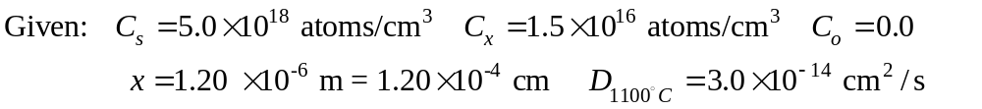

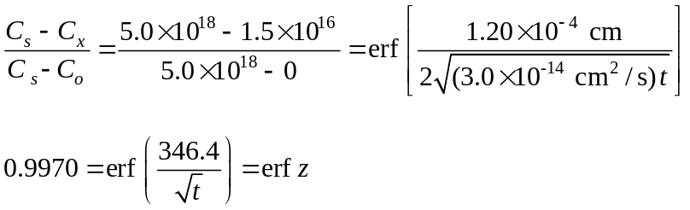

Interpolating from Table 5.3,
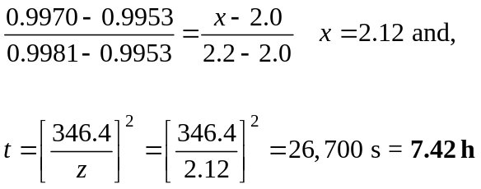

Chapter 5, Problem 27
Calculate the diffusivity D in square meters per second for the diffusion of nickel in FCC iron at 1100°C. Use values of D₀ = 7.7 × 10⁻⁵ cm²/s; Q = 280 kJ/mol; R = 8.314 J/(mol ⋅ K).

Chapter 5, Solution 27
The diffusivity of the nickel into FCC iron at 1373 K is:

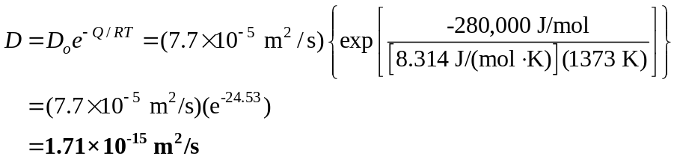

Chapter 5, Problem 28
Calculate the diffusivity in square meters per second of carbon in HCP titanium at 700°C. Use
D₀ = 5.10 × 10⁻⁴ m²/s; Q = 182 kJ/mol; R = 8.314 J/(mol ⋅ K).

Chapter 5, Solution 28
The diffusivity of carbon into HCP titanium is:

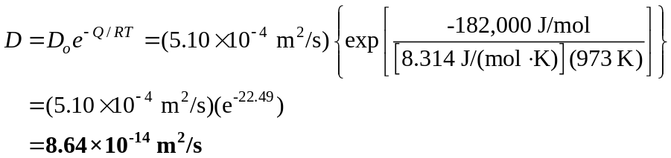

Chapter 5, Problem 29
Calculate the diffusivity in square meters per second for the diffusion of zinc in copper at 350°C. Use
D₀ = 3.4 × 10⁻⁵ m²/s; Q = 191 kJ/(mol ⋅ K), R = 8.314 J/(mol ⋅ K)..

Chapter 5, Solution 29
The diffusivity of zinc into copper at 623 K is:

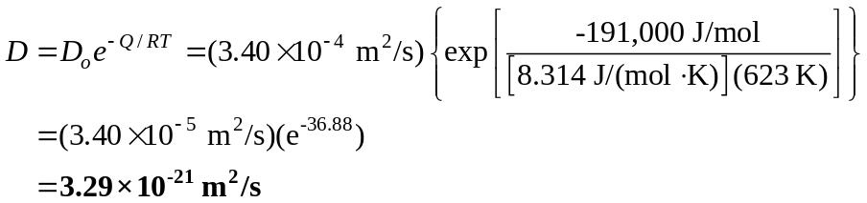

Chapter 5, Problem 30
The diffusivity of manganese atoms in the FCC iron lattice is 1.50 × 10⁻¹⁴ m²/s at 1300°C and 1.50 × 10⁻¹⁵ m²/s at 400°C. Calculate the activation energy in kJ/mol for this case in this temperature range. R = 8.314 J/(mol ⋅ K).

Chapter 5, Solution 30
The activation energy may be calculated using the Arrhenius type equation,

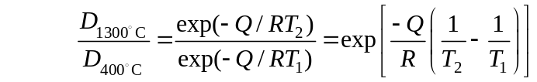

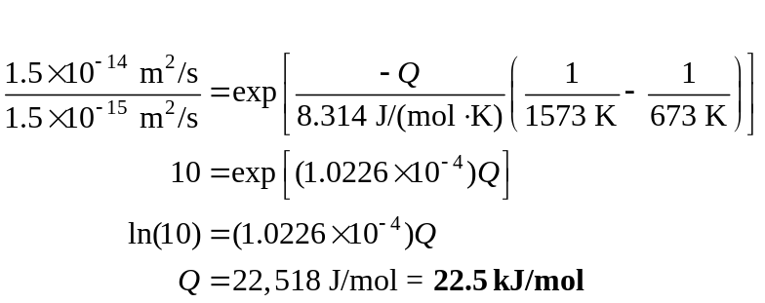

Chapter 5, Problem 31
The diffusivity of copper atoms in the aluminum lattice is 7.50 × 10⁻¹³ m²/s at 600°C and 2.50 × 10⁻¹⁵ m²/s at 400°C. Calculate the activation energy for this case in this temperature range. R = 8.314 J/(mol ⋅ K).

Chapter 5, Solution 31
The activation energy associated with copper diffusing into aluminum for this temperature range is,
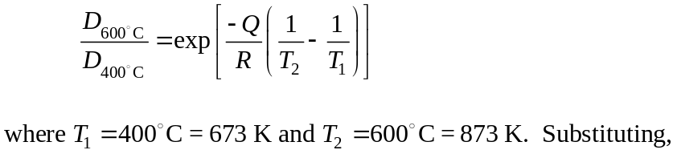

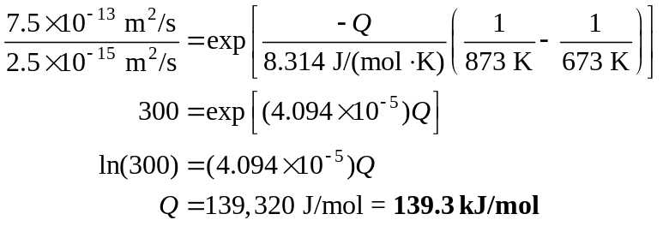

Chapter 5, Problem 32
The diffusivity of iron atoms in the BCC iron lattice is 4.5 × 10⁻²³ m²/s at 400°C and 5.9 × 10⁻¹⁶ m²/s at 800°C. Calculate the activation energy in kJ/mol for this case in this temperature range. R = 8.314 J/(mol ⋅ K).

Chapter 5, Solution 32
The activation energy associated with iron diffusing into BCC iron for this temperature range is,

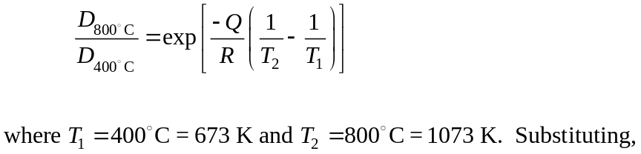

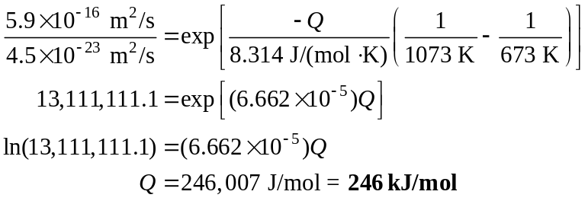

Chapter 5, Problem 33
The concentration of Manganese (Mn) at 500°C on the surface of an iron sample is 0.6 a%. At a distance of 2 mm below the surface, the concentration is 0.1 a/o. Determine the flux of Mn atoms between the surface and plane 2 mm deep. Hint: convert a% to atoms/m3 using information in Table 3.2.
Chapter 5, Solution 33
Convert atom % (a%) to atoms/m³.
For FCC iron, lattice constant a = 0.351 nm.
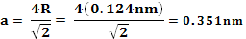
There are 4 atoms per unit cell.
Thus, 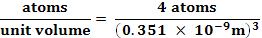
=
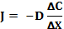 ; (metastable FCC ion)
ΔX = 0.002m
Surface
Surface

Chapter 5, Problem 34
The concentration of carbon on the surface of a 1018 steel gear is 0.8 wt% at 1000°C. Determine the flux of carbon atoms from the surface to a plane 25 mm below the surface where carbon concentration is unaffected by the surface concentration. Hint: convert wt% to atoms/m3 using information in Table 3.2.
Chapter 5, Solution 34
At 100°C, the structure of iron will be FCC.
Convert wt % to atoms/m³. (assume 100 grams)
- 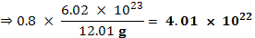 atoms of carbon in 0.8 g
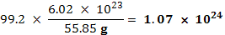 atoms of iron in 99.2 g
- For FCC iron, 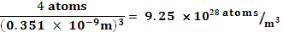
Note
The activation energy of nickel atoms in FCC
From (1) atom % carbon 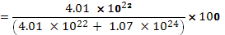 = 3.61 %
carbon concentration on the surface
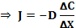 ; (carbon in FCC iron)
Carbon concentration 25µm below the surface is unaffected. Thus,

Chapter 5, Problem 35
A copper-zinc alloy (85wt% Cu-10wt% zinc) is coupled with pure copper (interfaced). The diffusion couple is then heated to a temperature of 1000°C. (a) How long will it take for the concentration of zinc to reach 0.2%, 2.5 mm below the interface? (b) How much will the zinc concentration at the same point be in twice the time calculated in part a?

Chapter 5, Solution 35
Copper is solvent, Zn is solute (non-steady diffusion)
interface
85% wt % Cu- pure copper
15% wt Zn
2.5 mm
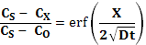

(amount of zinc present at the surface)
(concentration @ 2.5mm)
(pure copper)

; (table 5.2)
- 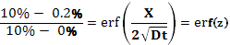

0.98 = erf (z) from table 5.3 using interpolation
z erf (z)
1.6 0.9763
z 0.9800
1.7 0.9838

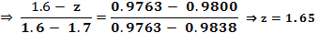
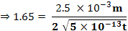

- 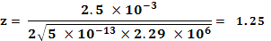 erf (z) = 0.916 from table 5.3
(increases by more than 4 times)

Chapter 5, Problem 36
A bar of pure nickel is coupled with a bar of pure iron (interfaced). The diffusion couple is then heated to a temperature of 1000°C. (a) How long will it take for the concentration of nickel to reach 0.1wt%, 1.0 mm below the interface? (b) How long will it take for the concentration of nickel to reach 0.1wt%, 1.0 mm below the interface? (c) What does the comparison of the two answers show?
Chapter 5, Solution 36
Iron is solvent, Ni is solute (non-steady diffusion); T = 1000°C

Ni Fe

1µm

(pure nickel)
(at
(pure iron)

(table 5.2)
- 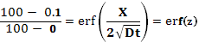

erf (z) = 0.999 ⇒ z = 2.8

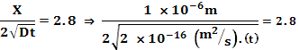
⇒ 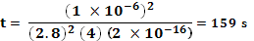

- For concentration of 0.1 wt % at 1.0mm
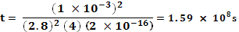
The conclusion is that diffusion is a slow process. Also, a small change in Δx (by a factor of 1000) will increase the time by a factor of 10⁶.

Chapter 5, Problem 37
The proportionality constant, Do, of carbon in HCP titanium is 25.5 times higher than carbon in FCC iron. The activation energy of carbon in HCP titanium is 1.28 times of carbon in FCC iron. Determine Q and Do for carbon in FCC iron. Verify your answers with those in Table 5.4.
Chapter 5, Solution 37
From table 5.2 @ 500°C:
;
⇒ 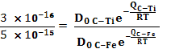
⇒ 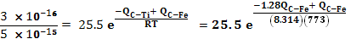
- ⇒ 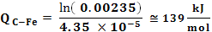 (table 5.4 142 kJ/mol)
- 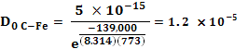 (table 5.4,

The differences are due to inaccuracies in relative measurement of and
.

Chapter 5, Problem 38
The proportionality constant, Do, of iron in BCC iron is 9.1 times higher than in FCC iron. The activation energy of iron in BCC iron is 89% that of iron in FCC iron. Determine Q and Do for iron in FCC iron. Verify your answers with those in Table 5.4.
Chapter 5, Solution 38
From table 5.2:
;
Thus, at 500°C,
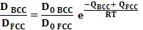
⇒ 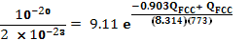
- ⇒ 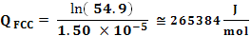 (table 5.4 268 kJ/mol)
- 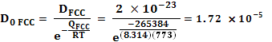 (table 5.4,
The differences are due to inaccuracies in relative measurement of and
. The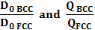 must be measured very accurately.

Chapter 5, Problem 39
The activation energy of nickel atoms in FCC iron is 280 kJ/mol and carbon atoms in FCC iron is 142 kJ/mol. (a) What does this tell you about the comparative diffusion of nickel and carbon in iron? (b) Can you explain why the activation energies are so drastically different? (c) Find a way to qualitatively explain how much energy is 142 kJ to a non-engineer or a non-scientist.
Chapter 5, Solution 39
- Since Q_{C-Fe} < Q_{Ni-Fe}, it can be concluded that carbon has an easier time diffusing in Fe than Ni atoms do in Fe.
- The difference in activation energies is due to differences in mechanisms (interstitial diffusion for C-Fe and substitution for Ni-Fe).
- You would need 4.2 J of heat to increase the temperature of one gram of water by one degree C. Thus, 142000 J would raise the temperature of 33,809 g (142000/4.2) of water by 1°C. Other ways to explain:
336 J to boil one gram of water
142000 J to boil 422 grams of water (or 0.422 kg)
Note that the activation energy is per mol. Therefore, the actual energy for practical applications will be significantly higher and depends on the number of moles.

Chapter 5, Problem 40
The melt temperatures of copper and aluminum are 1083°C and 657°C respectively. Compare the diffusivities of copper in copper and copper in aluminum at 500°C (use Table 5.2). Can you explain why a drastic difference exists?
Chapter 5, Solution 40
Copper has a higher melting temperature than aluminum. This means that the bonds between copper atoms are stronger and therefore harder to break. Diffusion will likely be more difficult in copper than aluminum.A second reason could be that although both metals are FCC, the void spaces in aluminum are larger (see example 4.3) since r_{Al} > r_{Cu}.

Chapter 5, Problem 41
The self-diffusion of iron atoms in BCC iron is significantly higher than in FCC iron (See Table 5.2). Explain why.
Chapter 5, Solution 41
The packing factor for BCC metals is lower than that of FCC metals. As a result, there is more space for diffusion in BCC iron (APF = 0.68) than in FCC iron (APF = 0.74).

Chapter 5, Problem 42
Would you expect the diffusion rate of copper (self diffusion) to be lower or higher in copper with ASTM grain size 4 than in copper with ASTM grain size 8? Explain your answer.
Chapter 5, Solution 42
There are more grains and grain boundaries in fine grained copper (the one with n=8). Grain boundaries are less efficiently packed and allow for higher diffusion rates. Thus, copper with ASTM grain size of 8 will have higher self diffusion.

Chapter 5, Problem 43
Would you expect the diffusion rate of copper (self-diffusion) to be lower in a pure copper sample that is loaded with dislocations or in a pure copper sample that is free of dislocations (refer to Sec. 4.4.2 for characteristics of dislocations)? Explain your answer.
Chapter 5, Solution 43
Metals loaded with dislocation possess higher stored energy. The atoms are forced out of their normal position and this causes lattice strain. The atoms have a higher state of energy than in an unstrained array. The extra energy could help with the diffusion process.

Chapter 5, Problem 44
In NaCl, would you expect the activation energy of cation (Na_) to be higher or the anion (Cl_)? Why?
Chapter 5, Solution 44
Cations are smaller in size than their bonding anions. This offers an advantage for higher rates of diffusion for cations. Na⁺ will have lower activation energy.

Chapter 5, Problem 45
Is the non-steady diffusion process more sensitive to temperature or time? Explain using appropriate equations.
Chapter 5, Solution 45
In the non-steady diffusion equation,

Note that time, t, appears in the denominator under the radical sign. Temperature, T, also appears in the same place through “D”.
Small changes in temperature, T, will cause large changes in D. Thus, cutting the temperature by half will have a more significant impact on the diffusion process than cutting the time by half.

Chapter 5, Problem 46
Show, using equations only, that as time increases in the gas carburization process, the concentration Cx increases.

Chapter 5, Solution 46
In the non-steady diffusion equation,
as time increases the denominator in the argument of erf also increases. As denominator increases, the argument 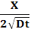 will decrease. As the argument becomes smaller, the 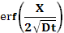 will also become smaller (see table 5.3). As becomes smaller, the differences between C_{S} and C_{X} also become smaller. Thus C_{X} is approaching C_{S} (becoming larger).

Chapter 5, Problem 47
If hydrogen diffuses in ferrous alloys, it will make the material significantly more brittle and susceptible to fracture. The activation energy of hydrogen in steel is 3.6 Kcal/mol. Should we worry about hydrogen embrittlement of steels (is it very likely to occur)? Explain.
Chapter 5, Solution 47
Compare the activation energy of hydrogen in iron (3.6 kcal/mol) to that of carbon in iron (29 to 34 kcal/mol) in table 5.4. It is clear that Q_{H-Fe} is 10 times smaller than Q_{C-Fe}. Now, consider the equation for diffusivity:
As Q is decreased by a factor of 10, -Q/RT also decreases resulting in a large increase in . We should be concerned with diffusion of hydrogen in ferrous alloys.

Chapter 5, Problem 48
In powder metallurgy, solid parts are formed by first densifying powder through pressure/compaction at room temperature. The particles are pressed against each other and form necks at the point of contact with each other (see Fig. P5.48a). The next stage is then sintering in which the densified compact is heated to elevated temperatures. The sintering stages are between 1000°C (Fig. P5.48b) and 1050°C (Fig. P5.48d). What observation can you make regarding the physical features of the compact going from the room temperature compact to sintering at 1050°C? What is the reason for this change?

Chapter 5, Solution 48
It is clear that high pressure alone cannot densify the powder to acceptable levels (see figure a). There is a great deal of porosity in figure a. However, as temperature is increased, the degree of porosity decreases significantly (compare figure a to figure d). The reduction in void space or densification of compact occurs because of diffusion across the contact areas between particles. Thus, diffusion is the main mechanism of densification.

